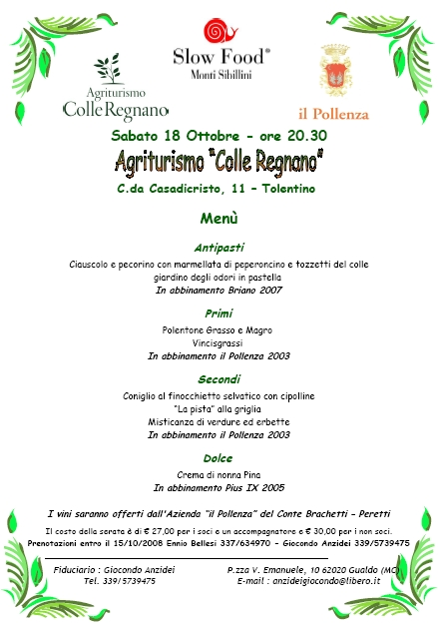


C.da Casadicristo, 11 - 62029 TOLENTINO (MC)
Tel. (+39) 0733.967691 Fax (+39) 0733.967691 Cell. (+39) 335.1278072
agriturismo@colleregnano.it www.colleregnano.it

